Deputy Librarian, Central Library
School of Planning and Architecture, Vijayawada
Institute of National Importance,
Ministry of Education, Govt. of India,
Sy. No. 4/4, ITI Road, Vijayawada-520008, Andhra Pradesh, India
91-9502593300 (M), 91-8662469466 (O)
Email: ysraoo@gmail.com, ysraoo@spav.ac.in
https://www.scopus.com/authid/detail.uri?authorId=36158964800
https://orcid.org/0000-0001-5551-8438
https://scholar.google.co.in/citations?hl=en&user=sxBC2yMAAAAJ
https://vidwan.inflibnet.ac.in//profile/88757
https://www.adscientificindex.com/scientist/ys-rao/3484566

Profile URL: https://vidwan.inflibnet.ac.in//profile/88757
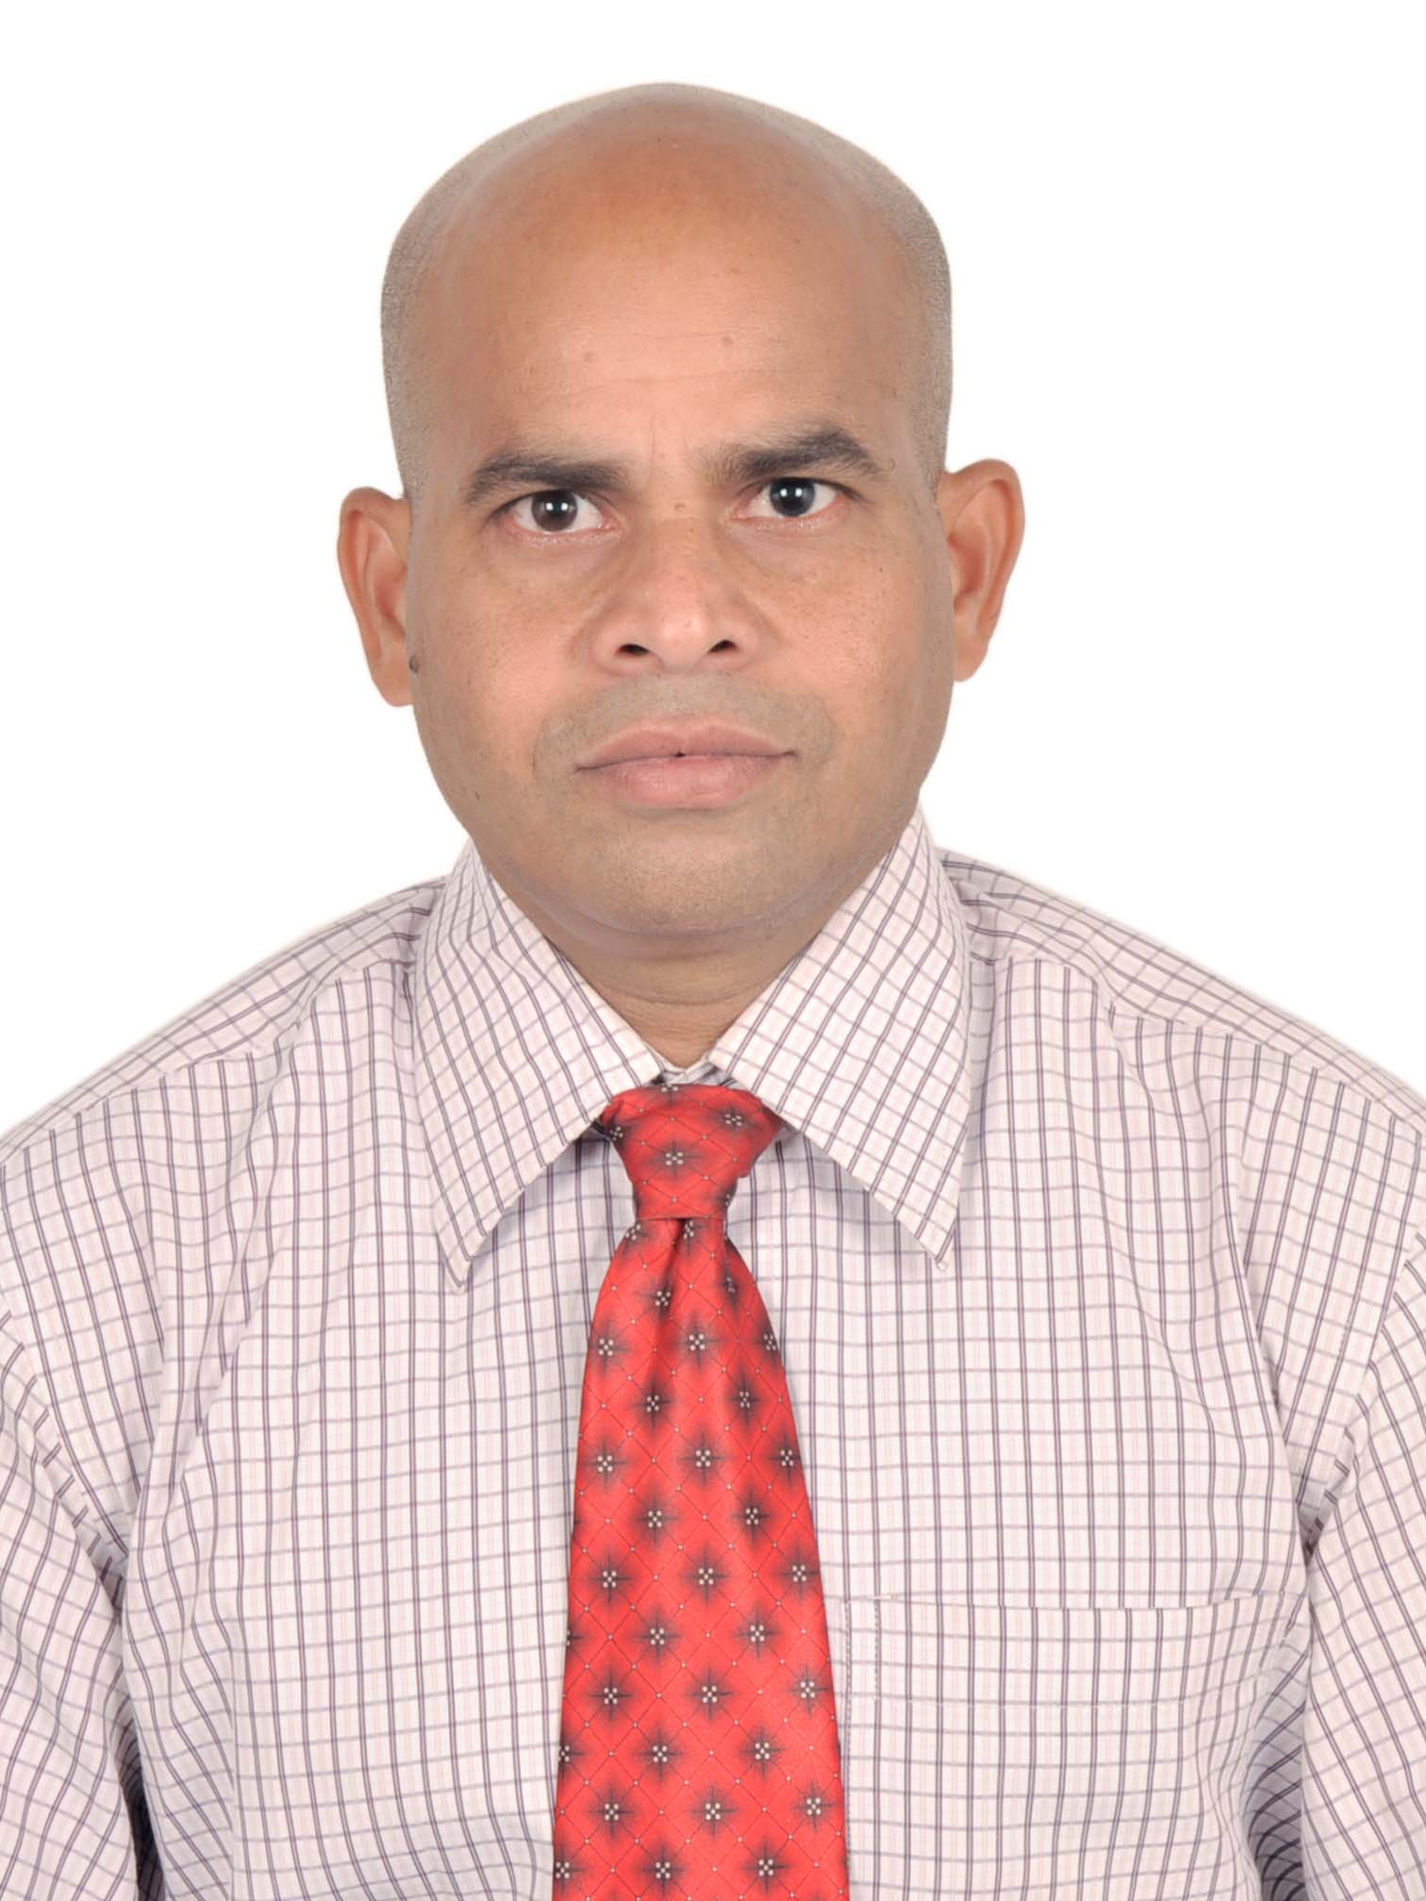

Dr Y. SRINIVASA RAO

Date of Birth : 01-06-1968
Passport No. : J7315669
Nationality : Indian
Languages : English – Hindi –Telugu
Marital Status : Married

Education
2010 | Ph.D. titled “Networked services of NIT libraries in India: an analytical study” under the guidance of Prof. BK Choudhury, Professor (Retd.), Department of LISc., Sambalpur University, Odisha
2002 | Post Graduate Diploma in Computer Applications (PGDCA) from Pondicherry University in Second Division (56.5%)
1997 | Master of Library and Information Science (MLISc) from Andhra University  in First Division (64.3)
1996 | * Bachelor of Library and Information Science (BLISc) from Andhra University in First Division (66.6%)
1994 | Master of Arts (MA) from Andhra University in Second Division (50%)
1989 | Bachelor of Arts (BA) from Andhra University in Second Division (53.3%)
2021 | General Course on Intellectual Property (Distance Learning Online) from WIPO ACADEMY

Honours/Awards

- Awarded Two Gold Medals in BLISC from Andhra University, Andhra Pradesh.
- Ayyanki Venkata Ramanaiya (Father of AP Library Movement).
- Yedluri Sesamamba.
- Secured First Rank in BLISc from Andhra University, Andhra Pradesh
- Merit Scholarship in BLISc from Andhra University, Andhra Pradesh.
- Awarded “Most Dynamic Librarian Award” for excellence and leadership in Education on 20.10.2020

Experience
2013 – Present | School of Planning and Architecture (SPA), Vijayawada, (Institute of National Importance, Ministry of Human Resource Development, Government of India) as Deputy Librarian
2004 – 2013 | National Institute of Technology (NIT), Rourkela, (Institute of National Importance, Ministry of Human Resource Development, Government of India) as Assistant Librarian
2000 – 2004 | Institute for Defence Studies and Analyses (IDSA), New Delhi,(Autonomous body, Ministry of Defence, Government of India) as Sr. Lib. Asst. & Lib. Asst.

Research Experience

1998 – 2000 | Institute for Defence Studies and Analyses (IDSA), New Delhi, (Autonomous body, Ministry of Defence, Government of India) as Research Assistant

Research Interest
- Academic Library System; Library Automation and Networking;
- Electronic Resource Management and Information Services;
- Intellectual Property Rights;
- Open Access and Institutional Repositories;
- Scholarly Communication

Training
1997 – 1998 | Defence Scientific Information and Documentation Centre (DESIDOC), (Ministry of Defence, Government of India) as Project Assistant

Academic Responsibilities @SPA Vijayawada

- Member Secretary, Institute Development of Plan (IDP) Committee (07.06.2024 to Till Date)
- Chief Warden from 14 March 2020 to 07.02.2024
- GEM-HOD I/C from 06.06.2022 to 10.07.2022 and 16-28 June 2024.
- In-charge and Dy. In-Charge for JOSAA/CSAB online counselling - 2014, 2017-2020, 2021, 2023
- Registrar I/C – 2017 (23-25 November, 18-22 October and December 7-8).
- Nodal Officer – National Institutional Ranking Framework (NIRF) –2017-2020
- Nodal Officer – Indian Research Information Network System, INFLIBNET, Ahmedabad– 2019
- Local Coordinator – Global Initiative for Academic Networks – 2017-2020
- Nodal Officer – FitIndia - Yoga and Health Club – 2018 – 2022
- In-Charge – Design and Development of Website – 2018 – 2020
- Chairperson – Stock Verification of Fixed Assets Committee -2020 and 2022
- Member – Science Week Festival – 22-22 February 2022.
- Member – Mental Health and Well-being Committee - 2020
- Member – Institute Publication Committee since 2019
- Member – Grievance Cell (2021-2022)
- Returning Officer for students Elections - 2017
- Member for Convocation Committee for 2015, 2016, 2018
- Member for Lease Negotiating Committee 2016
- Member for Annual Report Committee – 2016-2019
- Member of Recruitment Scrutiny Committee for the post of Legal Consultant and Admin and Finance Consultant – 2018
- Official for JOSAA online counselling - 2015 and 2016
- Official for CCMT online counselling – 2014

Membership
- Observer for NIMCET (NIT MCA COMMON ENTRANCE TEST) organised by the NIT Jamshedpur, Jharkhand for the year 2022
- Member, Board of Studies, Department of Library and Information Science, Andhra University, Visakhapatnam till 2020
- Expert Member of NIT AP – Library Advisory Committee for the year 2017-18.
- Member for International Librarians Network for the year 2016
- Member Andhra Pradesh Library Association (APLA), 2024
- Advisory Committee Member of INDEST-AICTE Consortium for NITs in the Eastern region for year 2010-13.

Interviews - Media

Interview with Doordarshan Saptagiri Career Program, regarding the Architecture for Admissions into JEE-Mains and NATA on.14.11.2019.

Interview with E-TV, Andhra Pradesh regarding the Admissions into NIT+ System on June 10, 2019 <https://www.youtube.com/watch?v=Z1kT2nvqy2U&feature=youtu.be>

Interview with E-TV, Andhra Pradesh regarding the Inaugural Ceremony of School of Planning and Architecture Vijayawada by Honorable Vice President and Honorable Governor on August 22, 2018. <https://www.youtube.com/watch?v=x72LFEoGrn8&app=desktop>.
- Interview with National Digital Library of India (NDLI) as representing from Andhra Pradesh on June 21, 2018 <https://www.facebook.com/ysraoo/videos/2375641832449676/UzpfSTEwMDAwMDExNjQ4MDg4NzozMzI0ODI0OTE3NTMxMzU4/>.
- Interview with Monday Morning on library developments on February 16, 2011 <http://mondaymorning.nitrkl.ac.in/index.php/campus/interview>
- Interview with Monday Morning on BPCL: Rendezvous with Y.S. Rao on February 13, 2012. <http://mondaymorning.nitrkl.ac.in/index.php/views/views/interview/1283-bpcl-rendezvous-with-ysrao>
Reviewer Experience

- Reviewer for an International Journal of Library and Information Science - www.ms.academicjournals.org- (ID No. IJLIS/06.01.15/0544 dated 07 January 2015).
- Reviewer for the Electronic Library (ID No. EL-06-2016-0128 dated 25 July 2016).
- Reviewer for an International Journal of Library and Information Science - www.ms.academicjournals.org- (ID No. IJLIS-14.09.16-0741 dated 17 September 2016).
- Reviewer for the Journal of Medicine and Life (# JML-2021-0174) on 01.09.2021.

Citations and H-Index and i10 Index

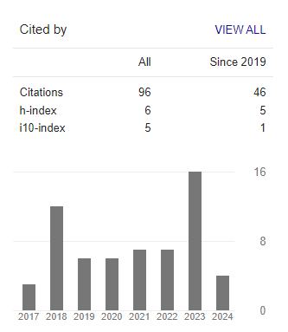

Research Publications
(International and National Journals)

Sl. No. | Title of the Paper | Journal Name  (Vol. / Issue No. Page No.) | Year | ISSN No. | Indexed Journals
1 | Scientific publication process and its impact on growth of science | Annals of Library and Information Studies, 68(1), 13-20.  http://nopr.niscair.res.in/handle/123456789/57116 | 2021 | 0972-5423 | Scopus Indexed Jr.
2 | Users’ perceptions toward ICT facilities at the National Institute of Technology (NIT), Rourkela: A case study | Journal of Library, Information and Communication Technology, 10(1),  37-46.  http://escienceworld.in/index.php/jlict/article/view/205/158 | 2018 | 0975-3168 | Reviewed
3 | C5 Model for the Consortium Management: SWOT Analysis | Library Management, 38(4/5),  248-262.  https://doi.org/10.1108/LM-09-2016-0073 | 2017 | 0143-5124 | Scopus Indexed Jr.
4 | Performance among NIT libraries in India with respect to resource facilities | VSRD International Journal of Technical & Non-Technical Research, VI (May), 191-201. http://www.vsrdjournals.com/docs/VSRDTNTR_May_2015_Special_Issue.pdf | 2015 | 2319-2216 | Reviewed
5 | Correlation among Library Facilities: an Analytical Study | Library Philosophy and Practice, 12-668. e-journal.  http://unllib.unl.edu/LPP/rao.htm | 2011 | 1522-0222 | Scopus Indexed Jr.
6 | Computer Infrastructure Facilities at NIT Libraries in India: A Study | DESIDOC Journal of Library and Information Technology, 30(01),  32-37.  http://hdl.handle.net/2080/1156  https://publications.drdo.gov.in/ojs/index.php/djlit/article/view/282/4409 | 2010 | 0974-0643 | Scopus Indexed Jr.
7 | Influence of Factors in Provision of Networked Services: An Empirical Study in India | Library Philosophy and Practice, 3-337, e-journal.  http://hdl.handle.net/2080/1208 | 2010 | 1522-0222 | Scopus Indexed Jr.
8 | Networked Services of NIT Libraries in India: A Study | Library Collections, Acquisitions, and Technical Services, 34(4), 105-114  http://dx.doi.org/10.1016/j.lcats.2010.05.004 | 2010 | 1464-9055 | Scopus Indexed Jr.
9 | Network Infrastructure Facilities: A Case Study of NIT Libraries in India | International Journal of Library Science, 01 (J10), 01-11  http://hdl.handle.net/2080/1206 | 2010 | 0975-7546 | UGC listed Jr.
10 | Library Automation Facilitation: A Case Study of NIT Libraries in India | Computer in Libraries, 29(10), 41-44.  http://hdl.handle.net/2080/1261 | 2009 | 1041-7915 | Scopus Indexed Jr.
11 | Information Technology Services (ITS): A Role of Information Practitioners | Information Age, 2(1), 05-11.  http://hdl.handle.net/2080/601 | 2008 | 0973-7073 | Reviewed

Research Publications
(Books, Chapters in Books)

Subject Books by national level publishers with ISBN
Sl. No. | Name of the Book | Year/ Publisher (National) | ISBN | Reviewed/ Non-reviewed
 | Scholarly Communication,  Open-access Publishing and Ethics | 2018,  BS Publication, Hyderabad | 9789387593923 | Reviewed
 | Abstracts of Scholarly Communication,  Open-access Publishing and Ethics  E-book ISBN 978-81-936820-3-6  DOI: https://doi.org/10.21467/proceedings.3 | 2018,  AIJR Publication, Balrampur | 9788193682043 | Reviewed
 | Scholarly Communication and Intellectual Property Rights | 2014,  BS Publication, Hyderabad | 9789383635191 | Reviewed

Chapters in Books with ISBN
Sl. No. | Name of the Book | Title of the Paper/Chapter with no. | Year/ Publisher (National) | ISBN | Reviewed/ Non-reviewed
 | Digital Institutional Repositories: Case Studies | Institutional Repository Enhances Visibility and Prestige of the Institute the Case of NIT Rourkela. | UCFAI University, Press Hyderabad: (pp.41-50). | 8131412932 | Reviewed
 | Modernisation of Libraries: A Challenge in Digital Era | Collaborative Networked Library System and Services: an overview. | Mahamaya Publishing House. New Delhi, (pp.165-176). | 8183250535 | Reviewed

Type of Events | Published | Organized as Coordinator | Participated & Presented Papers | Participated | Total
Journals  (Both National & International) | 11 | 0 | 0 | 0 | 11
Books | 3 | 0 | 0 | 0 | 3
Chapters | 2 | 0 | 0 | 0 | 2
Conferences | 0 | 2 | 8 | 1 | 11
Workshops | 0 | 6 | 5 | 7 | 18
FDP | 0 | 3 | 3 | 0 | 6
Seminars/Symposia | 0 | 1 | 4 | 1 | 6
Webinars | 0 | 3 | 6 | 4 | 12
Invited Lecture | 0 | 0 | 11 | 0 | 11
Training | 0 | 1 | 0 | 2 | 3
Total | 16 | 16 | 36 | 15 | 83

Events Organised as Coordinator
(Conference/Workshop / FDP Seminar/Webinar)

Sl. No. | Events Organised  (Conference/Workshop / FDP Seminar/Webinar) | Organising Institution | Category /  Type of Event | Date of Event
 | Workshop on “Yoga Retreat” | Fit India-Yoga & Health Club | University | 20-22 June 2022
 | Seminar on “Stress Management” | Mental Health Well-being Committee (MHWBC), SPA Vijayawada | University | 27 April 2022
 | Webinar on "Art of Mind Control through Yoga and Meditation" | Fit India-Yoga & Health Club, SPA Vijayawada | University | 19 June 2021.
 | Webinar on "Searching Tools and Techniques to Enhance Research Methodology" | SPA Vijayawada | University | 14 August 2020.
 | Webinar on “Creating Awareness on Turnitin” (CAT) | SPA Vijayawada | University | 10 August 2020
 | One Week FDP on “Communicating Research and Open-access Publishing” (CROP-2019) at SPA Vijayawada during. | SPA Vijayawada | National | 17-22 June 2019
 | Conference on “Scholarly Communication, Open-access Publishing and Ethics” (SCOPE-2018) | SPA Vijayawada | International | 25-26 October 2018
 | One week FDP on “Planning Implementation: Delivering Best Practice with an Awareness of Barriers” | GIAN Program at  SPA Vijayawada | National | 03-07 October 2017
 | One week FDP on “Rethinking architecture, energy efficiency and participation in urban development” | GIAN Program at  SPA Vijayawada | National | 13-18 Aug 2017
 | Regional (South – IV) Workshop on “Institutional Digital Repository” (IDR-2017) | SPA Vijayawada and IIT Kharagpur under National Digital Library Project, ME, Govt. of India | National | 21-22 April 2017
 | Workshop on “Scholarly Communication and Plagiarism” | SPA Vijayawada | University | 07 November 2016.
 | Workshop on “Access to Online Resources: Way for Education, Research and Innovations” (AORERI-2015) | SPA Vijayawada | National | 07 March 2015.
 | Conference on “Scholarly Communication and Intellectual Property Rights” (SCIPR-2014) | SPA Vijayawada | National | 04-05 August 2014
 | Workshop on “Use of E-books and its future” | NIT Rourkela | National | 13-14 January 2012.
 | Workshop on “Library 2.0 Practices” | NIT Rourkela | National | 15-17 January 2009
 | Offered Training to Apprentices (Graduate/Diploma) in the field of Library and Information Science (LISc) | NIT Rourkela | National | 2005 to 2013

Events Participated and Presented Papers
(Conference/Workshop / FDP Seminar/Webinar)

Sl. No. | Title of the Invited Lecture delivered/  Paper presented | Details of Conference / Seminar/ FDP and Organising Institution | Category/  Type of Event | Date of Presentation
1 | Significance of Patents | Invited Lecture at Centre of Excellence for Research, PP Savani University, Gujrat, | National | 27.08.2022
2 | Future Libraries at Service Platforms | National Conference on “Knowledge Feast 2021: EBSCO CatchUp” Organized by EBSCO at Taj-The Gateway Hotel, MG Road, Vijayawada | National | 30-11-2021
3 | RIGHTS (Research Integrity, Governance, Human Transformation and Services) | Webinar on Research Ethics, Integrity and Data Management Organised by the Sambalpur University, Sambalpur, Odisha | National | 09-09-2020
4 | Academic Integrity & Plagiarism Policy for SPAV | Webinar on Creating Awareness on Turnitin Organised by the SPA Vijayawada | State/Univ. | 10-08-2020
5 | Librarian Plays Cards | 18th Virtual Webinar host by DP Tripathi. NIT Rourkela; Streamed live on Aug 2, 2020 https://www.youtube.com/watch?v=6yyhOFs9DzE | National | 02-08-2020
6 | Libraries Vision and Mission | 17th Virtual Webinar on Service Delivery Models for Library and Library Professionals  https://youtu.be/FreDDR5At1E | National | 24-07-2020
7 | Libraries Vs Librarian | National Webinar on Future Libraries: Role of the Library and Information Science Professionals, organized by the Aditya Educational Institutions, Kakinada. https://qrgo.page.link/6smdp | National | 18-07-2020
8 | Library Research Methods for MPhil Students | Department of Political Science, Mahatma Gandhi Kashi Vidyapith, Varanasi | National | 23-05-2020
9 | Library Orientation: Access to E-resources | SPA Vijayawada | State/ Univ. | 14-03-2020
10 | Institutional Resources, Research and Repository (R3) | NDLI Club - Guntur Regional Workshop at Eswar Engineering College, Narasaraopet, Guntur | State/ Univ. | 21-12-2019
11 | Implications of Intellectual Property Rights for Libraries | International Conference on Next Generation Libraries-2019 (NGL-2019) organized by the Central Library, NIT Rourkela | International (within country) | 13-12-2019
12 | Natural Language Processing and Copyright Issues | FDP on at Department of Computer Science Engineering, NIT Rourkela | National | 11-12-2019
13 | Communicating Research and Open-Access Publishing | FDP on Communicating Research and Open-Access Publishing (CROP) at SPA Vijayawada during June 17-22, 2019 | National | 18-06-2019
14 | Intellectual Property Rights in India: Role of Architects | SPA Vijayawada | State/ Univ. | 14-03-2019
15 | Utilization of E-resources and Open Access | Guest Lecture at Andhra Loyola Institute of Engineering and Technology (ALIET), Vijayawada | State/ Univ. | 22-02-2019
16 | Digital Inclusive Libraries | Workshop on Managing the Libraries in Digital era: Trends and challenges Tirumala Engineering College, Narasaraopeta, Guntur, AP | State/ Univ. | 24-11-2018
17 | Scholarly Communication Cycle: SWOT Analysis | International Conference on “Scholarly Communication, Open-access Publishing and Ethics” (SCOPE-2018) at SPA Vijayawada during October 25 – 26, 2018 | International (within country) | 26-10-2018
18 | Academic Currency | Workshop on Scholarly Communication and Plagiarism at SPA Vijayawada | State/ Univ. | 07-11-2016
19 | Role of Consortium in an Academic Setting | National Workshop on Access to Online Resources: Way for Education, Research and Innovations (AORERI-2015) at SPA Vijayawada | National | 07-03-2015
20 | Intellectual Property Rights in India: Significance of Patents | National Conference on Scholarly Communication and Intellectual Property Rights (SCIPR-2014), at SPA Vijayawada during August 04-05, 2014 | National | 05-08-2014
21 | Plan for Setting up Institutional Repository at Mahatma Gandhi Antarrashtriya Hindi Vishwavidyalaya | National Conference on Scholarly Communication and Intellectual Property Rights (SCIPR-2014), at SPA Vijayawada during August 04-05, 2014 | National | 04-08-2014
22 | Strategy for promoting IPR in India | Ten Day Research Methodology Course for PhD Students” at NIT Rourkela during March 20-29, 2013 | National | 26-03-2013
23 | Science, Engineering Research and Innovation in Academic Libraries (SERIAL) | National Symposia of Library Connect organized by the Elsevier Science at Trident Hotel, Bhubaneswar | National | 14-02-2013
24 | Content is King for Innovative Society | National Seminar on Creativity and Innovation Management at Sambalpur, University, Sambalpur | National | 22-12-2012
25 | Patent Search: a way for Innovation | Seminar on Patent Search and Patenting at NIT Rourkela | State/ Univ. | 24-03-2012
26 | E-books: Ten Questions | National Workshop on Use of E-books and its future organized by the NIT Rourkela | National | 13-01-2012
27 | Introduction to Operating System | PGDLAN Course at Sambalpur University, Sambalpur | State/ Univ. | 07-08-2011
28 | Information and Network Society | PGDLAN Course at Sambalpur University, Sambalpur | State/ Univ. | 07-08-2011
29 | National Information Infrastructure | PGDLAN Course at Sambalpur University, Sambalpur | State/ Univ. | 07-08-2011
30 | Availability of Electronic Resources at NIT Libraries in India: A Study | International Conference on Academic Libraries (ICAL-09), Organized by the Delhi University, Delhi during 05-08 October 2009. http://hdl.handle.net/2080/1157. | International (within country) | 08-10-2009
31 | Computer and Society | PGDLAN Course at Sambalpur University, Sambalpur | State/ Univ. | 16-07-2007
32 | Information and Network Society | PGDLAN Course at Sambalpur University, Sambalpur | State/ Univ. | 16-07-2007
33 | National Information Infrastructure | PGDLAN Course at Sambalpur University, Sambalpur | State/ Univ. | 16-07-2007
34 | Societal Implications of Information Technology Services | National Conference on Technological Advances and Emerging Societal Implications at NIT Rourkela, Odisha during March 24-25, 2007. | National | 25-03-2007
35 | Semantic Web: an Organized Way for E-resources | National Seminar Proceeding on Librarianship in 21st Century at Sambalpur University | National | 16-02-2007
36 | Institutional Repository Enhances Visibility and Prestige of the Institute the Case of NIT Rourkela | National Conference on Information Management in Digital Libraries organized by the IIT Kharagpur during August 2-4, 2006. | National | 03-08-2006
37 | Use of e-library: training program for students and teachers | NIT Rourkela | State/ Univ. | 26-01-2005

Events Participated
(Conference/Workshop / FDP Seminar/Webinar)

Sl. No. | Events Organised  (Conference/Workshop / FDP Seminar/Webinar) | Organising Institution | Category /  Type of Event | Date of Event
 | Coexistence of Academic Integrity and AI in Academia | Turnitin, South Asia. | International | 14 July 2023
 | Role of the Print and Electronic Media for Science Popularisation in Andhra Pradesh and Telengana | NIT Warangal, SCoPE Project of Vigyan Prasar, DST at School of Planning and Architecture, Vijayawada, | Regional | 16 July, 2022
 | First International Seminar of SLA Asian Community 2021 | Special Library Association-Asia | International | 30 Mar 2021
 | Webinar on “Read Quality-Publish Quality-Write Effectively” | Mahatma Gandhi Central University | International | 11 June 2020
 | Webinar on How to Publish and Succeed with Open Access Publications | Jointly organised by IIT Delhi and Taylor & Francis Group, India | International | 10 June 2020
 | Webinar on “SLA Asian Chapter Webinar – Advocacy for the Library in Higher Education” | Special Library Association-Asia | International | 04 May 2020.
 | Webinar on “Transferable Skills: Tips for Library Career Transitions” | Special Library Association-Asia | International | 14 May 2020.
 | National workshop on Copyright issues in Digital Libraries | National Digital Library, IIT Kharagpur | National | 09-10 Feb 2018
 | Seminar on “Delivery of Books and Newspapers (Public Libraries) Act, 1954 Amended 1956” | National Library, Kolkata in association with Andhra Loyola College, Vijayawada | National | 27-28 November 2015
 | Training Program on “Personality Development: an Ordinary to Extra- ordinary Personality Empowerment” | Engineering Staff College of India, Hyderabad | Institutional | 26-28 June 2013
 | Workshop on “E-learning for Librarians” | TEQIP, NPIU at Pune Institute of Eng. and Technology (PIET), Pune | National | 17-18 January 2006
 | Workshop on “Knowledge Management” | NIT Karnataka, Suratkal | National | 22-24 December 2004
 | Workshop on “INDEST and 2nd Annual Meet” | INDEST Consortium at IIT, Delhi | National | 31 August -  01 Sept. 2004
 | Workshop on “Institutional Repositories” | INDEST Consortium at IISc Bangalore | National | 27-29 July 2004
 | Workshop on “Use of INDEST Online Resources” | MHRD, Govt. of India at IIT, Kharagpur | National | 10 – 11 April 2004
 | Workshop on “Web Portal Development” | Central Secretariat Library, Dept. of Culture, Ministry of Tourism and Culture, Govt. of India, New Delhi | National | 17 – 19 November 2003.
 | 4th Conference on Asian Security | IDSA, New Delhi | International | 18-19 March 2002.
 | Training Program in the project of Ranganathan Research Circle | DESIDOC, Ministry of Defence, Delhi-110054 | Institutional | 1997 August 1998.


Date : 09.07.2024

Place : Vijayawada, AP SIGNATURE

